We could deal with Ass1 through several parts:
In the first part:
We should get the name through string ‘Sir’ and ’Sirs’.Luckily,’re’ module could help us split the word in text.You could google ‘python re.split’,it is used to split through several strings at the same time.I use re.split(‘[.!”,? ]’,line) to get all words. 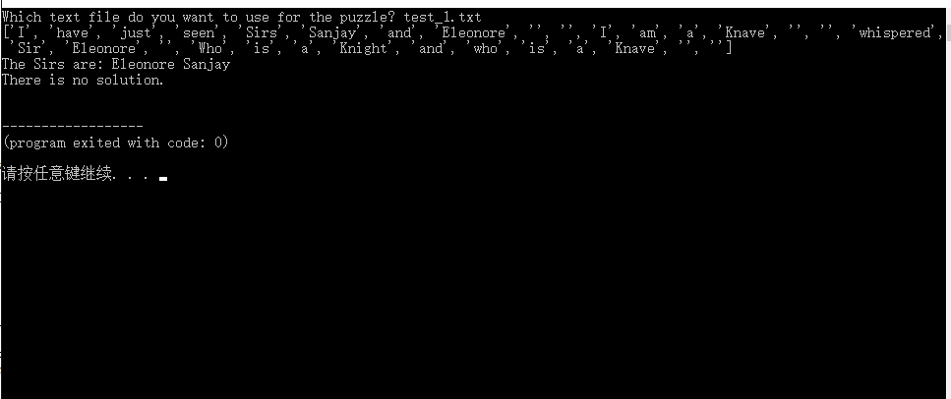

The result looks like above.You will find that the list contains some ‘ ’,I use’ for loop’ and if i==’ ‘:list.remove(i) to remove it.Then we need to find the index of Sir or Sirs and get the name by [index+1] or [index+n].Remember to remove the string ‘I’.eg. Sir Rex and I
Finally,we get a name list like: [‘A’,’B’,’C’]

第二步:
第二步的最终目的是得到一个字典：
The second part:
The goal of second part is to make a dict:
{name:[[[sentence1(we just need the name between double quotes)],the pattern of sentence][[sentence2],the pattern of sentence]}
We could use replace(‘ .” ’, ’ ”.’ ) to make a sentence Sir A says:”asdasd.” become Sir B says:”asdasd”. And we also could use re.split() and ‘.?!’ to get the whole sentence. 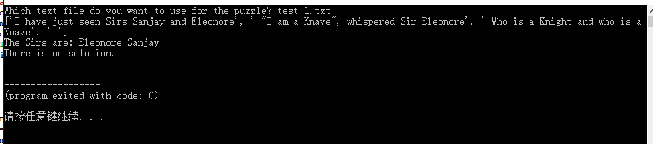
Then we could use if ‘ ” ’ in sentence: to remove some useless sentences.
2、2.1
There are two possible forms:Sir A says:”asdas” or ”sadasd”,Sir A says.
We could use name1,sentence,name2=re.findall('(.*)"(.*)"(.*)',i.strip())[0] to deal with it at the same time. If it is the first form,the name2 will become’ ‘.If it is the second form,the name1 will become ‘ ‘.
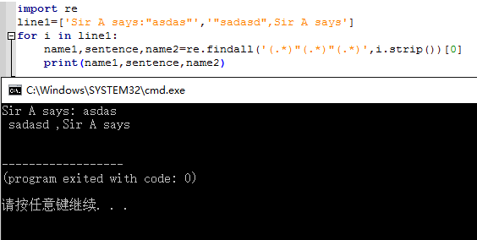
Just use two if to remove ‘ ‘
2.2
Then we need to get the speaker’s name and the name between double quotes through the way in first part.The reason why I make the name list in the first part is that we could use the index of name instead of strings. If we meet I , we could append the index of speaker.If we meet us,we could append all indexes of name in name list.
Eg: Sir A says:”Sir B and Sir C are Knight”
Name list:[‘A’,’B’,’C’]
Speaker is ‘A’,name_in_talking are [‘B’,’C’]
speaker=0,name_in_talking=[1,2]

2.3
Then we need to get the form of sentence between double quotes.There are 8 kinds of forms.(we just need to discuss 3 kinds of forms,but I suggest we discuss 8 kinds at the first time).We could get the form by key words.
Eg.At least one of Conjunction_of_Sirs/us is a Knight/Knave
Use if’ At least’ in sentence:
You need to be careful when using ‘in’
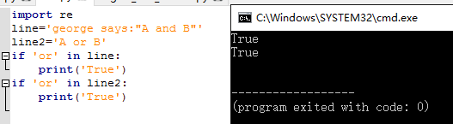
Because george contains ‘or’,the result is still True.
So I suggest we should use several key words like : If ‘a’ and ’b’ in line:
I use number ‘0-7’ to indicate the form of sentence and number 1,0 to indicate knight and knave.Finally we could get a dict like this: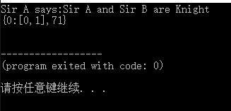

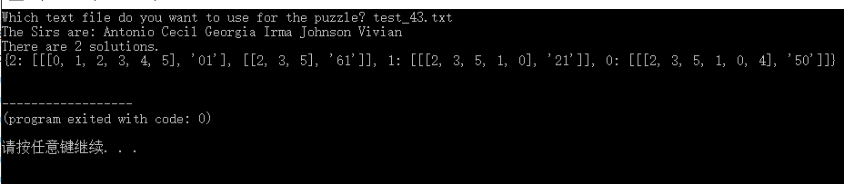

3 The final part is to get possible solutions 。
3.1
There are several ways to create truth table.I use product which is taught in class.
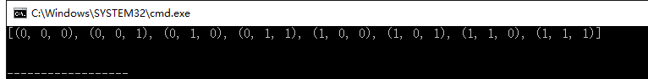
It is difficult to explain this part.I offer my for loop at the beginning of my code
for ways in truth_table:
for i in dict.keys:
for sentence in dict[i]:
It means you need to think about each possible truth,and think about the speakers in this truth,and then think about each sentence talked by this speaker.
And then, you need to think about two situations. If this guy is knight, if this guy is knave.There are 8 kinds of forms,so we need write 16 if sentences.(we could reduce it,but I suggest you write it one by one at the first time)
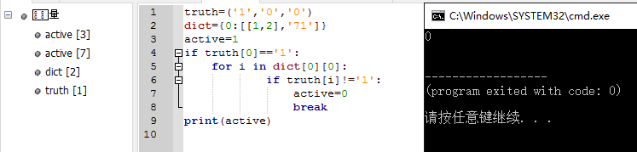
This means: Sir A says:”Sir B and Sir C are Knight”
Name list:[‘A’,’B’,’C’]
If Sir A is knight,Sir B and Sir C should be knights.If not,active=0 and break.
Remember,if active=0,use break or continue to end the loop.This will save a lot of time.It could get a result within 3seconds when the number of names is below 20.

If possible,I hope to share my ideas in next assignment by video.Today is 30th Mar,you still have time.Don’t give up!

